Helm basics:

1. Helm create my-chart 🡪 This creates a default chart with nginx image. 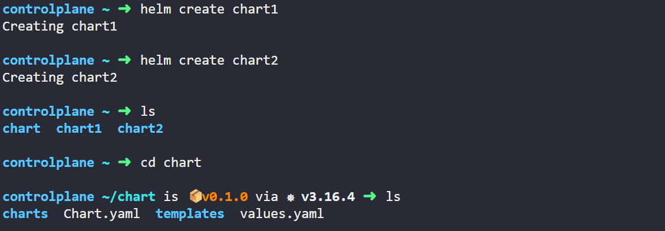
2. Helm package chart 🡪 That creates a gz (archive) 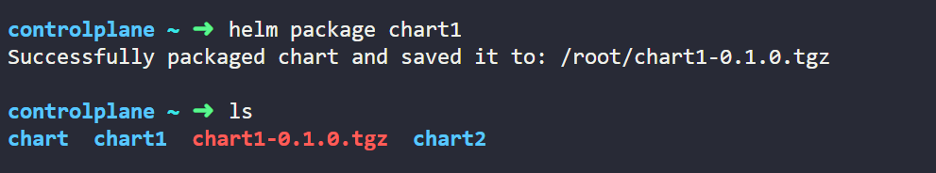
3. helm show all chart 🡪 shows all the information related to the chart
4. helm show values chart 🡪 shows the values of values.yaml
5. helm pull chart 🡪 downloads a particular chart from URL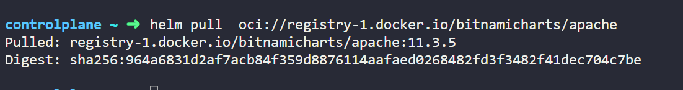
6. helm install my-release <url> 🡪 directly install the chart as a release (application)
7. helm uninstall my-release 🡪 directly uninstall the release and its componenet
8. helm repo [add][list][update][remove] 🡪 standard operations on repo. 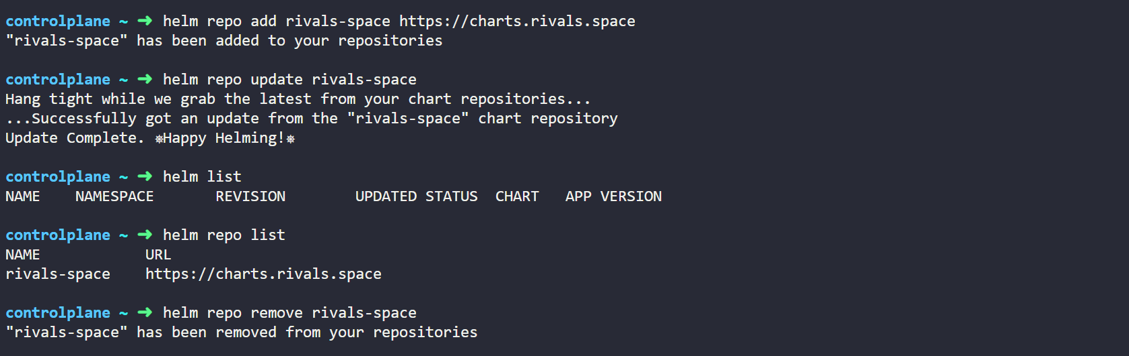
9. helm search repo <repo-name> 🡪 list all the charts present in a repo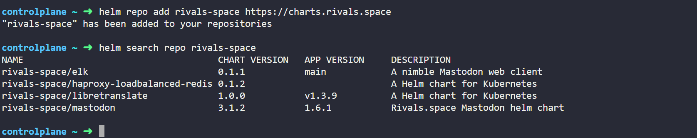
10. helm search repo <repo-name> --versions 🡪 check versions of all the charts present in the repo. 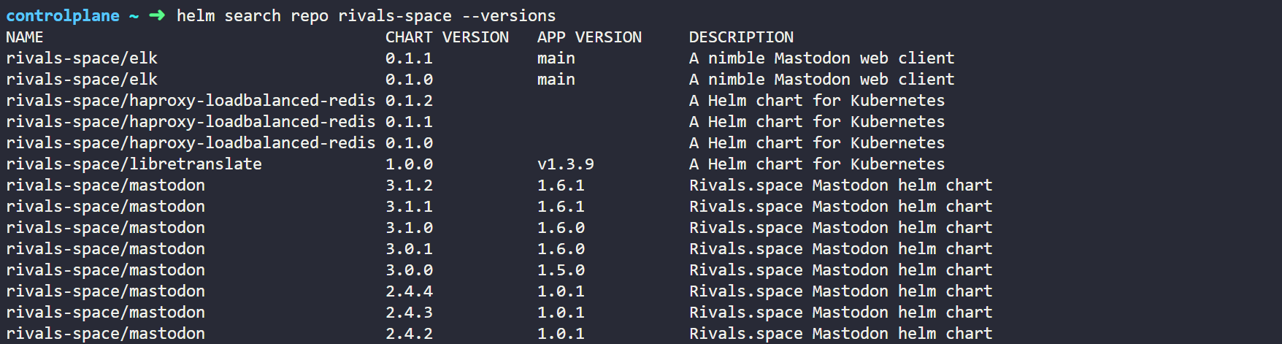
11. Helm release management is the most straightforward, you can find all the basic commands here 🡪 <https://helm.sh/docs/intro/cheatsheet/>
12. helm get manifest my-release 🡪 check all the manifest (yaml) files installed by the chart. 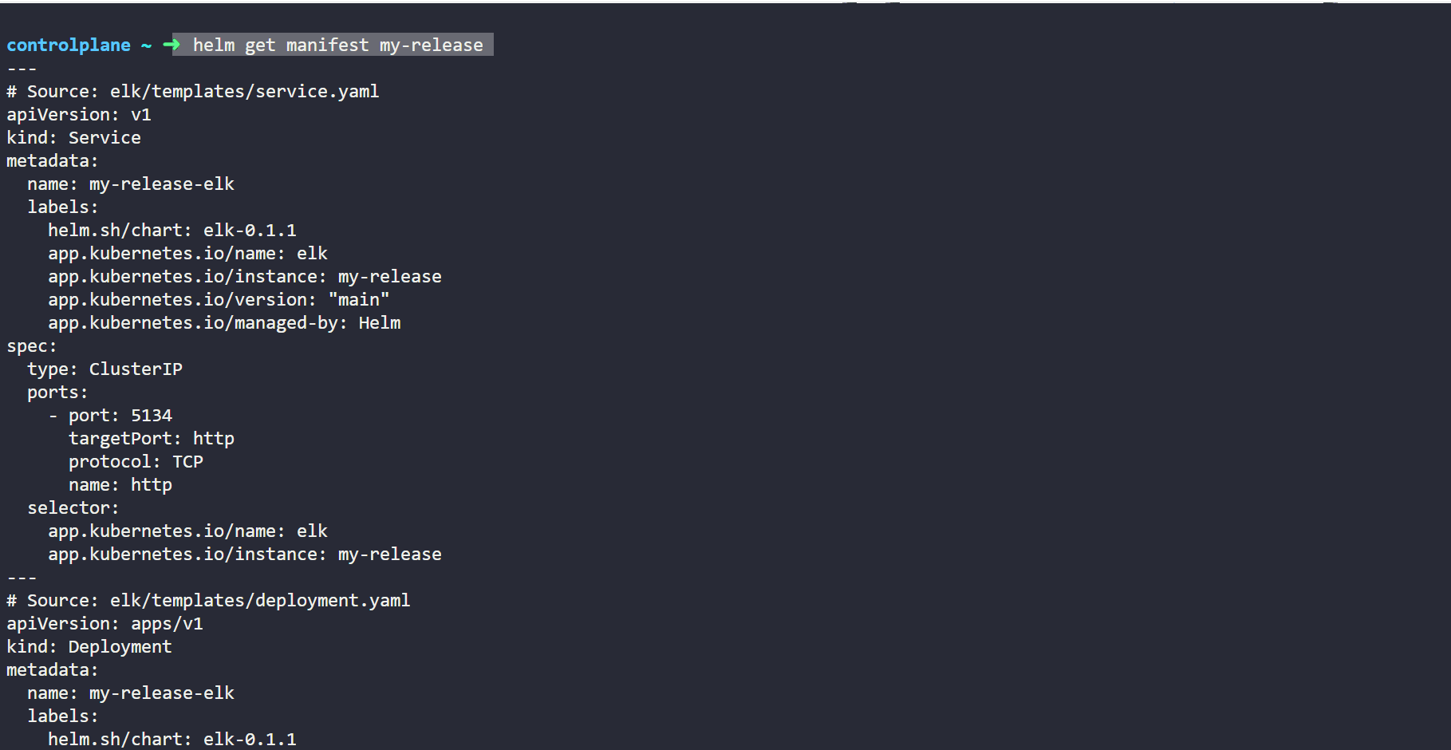
13. Helm status my-release 🡪 this will tell the status, if the release was successful or not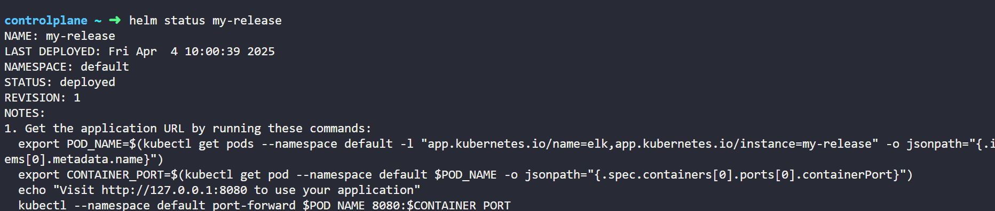
14. You can use custom values and install or upgrade the chart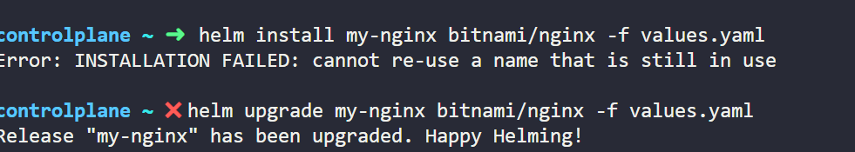
15. Helm rollback my-release 2 (revision number)
16. helm install my-app bitnami/nginx --set service.type=LoadBalancer (to set a particular parameter in a release)
17. Correct way to upgrade an image to another version: helm upgrade my-nginx bitnami/nginx --version 18.3.5 